Project Design Phase-I Solution Architecture

|  |  |
| --- | --- |
| Date | 19 oct 2022 |
| Team ID | PNT2022TMID01380 |
| Project Name | Smart Fashion Recommendation Application |
| Maximum Marks | 4 Marks |

Solution Architecture:

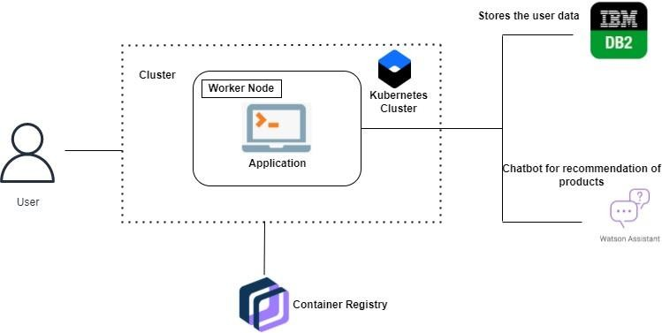

Example - Solution Architecture Diagram:

|  |
| --- |
| IDENTIFICATION AUTHERIZATION |
| IDEAL INFORMATION |
| MOST FREQUENT  SEARCH |
| MARCHENT  COMMUNICATION AND COST |



**USER INTERNET**

**PRODUCT DETAILS DATABASE**

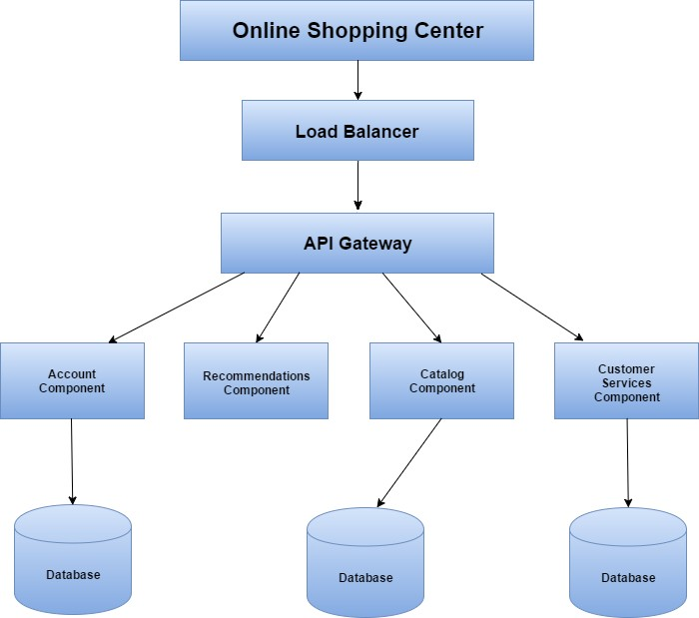

Solution architecture diagram for smart fashion recommendation application